Week 12 visualization David Zhu

<https://www.behance.net/gallery/106936329/Plastic-Waste-Pollution-data-visualisation>

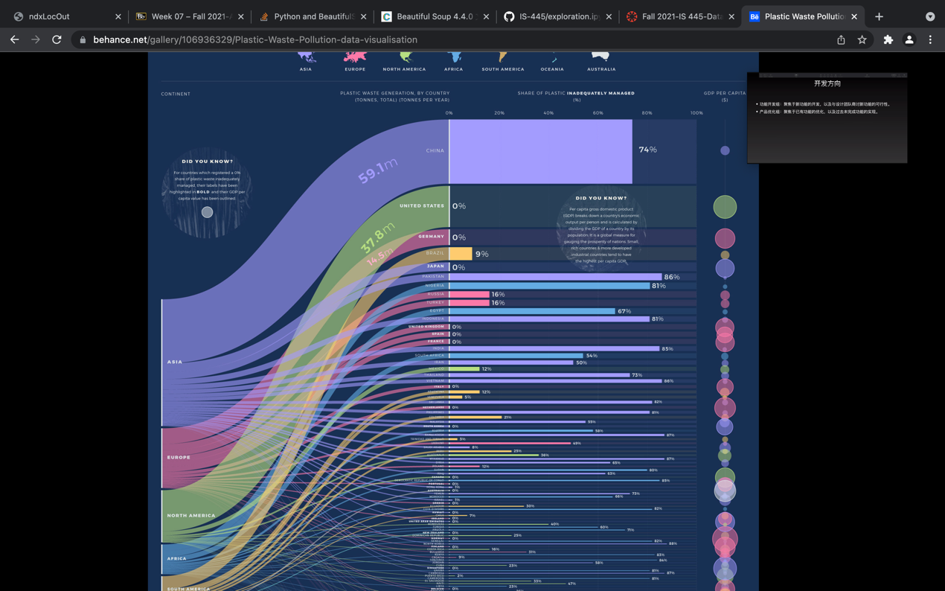

This is a visualization for plastic pollution worldwide. This graph use different colors as different continents and matches the same entry with corresponding country. This plot is good at visualizing the amount and relationship between different countries, and it also has a pleasing color choice. But the percentage in the right is a bit hard to understand. Also, the lines at the bottom is so hard to see and condensed. It is hard to read what the country name is and where it is connected to.